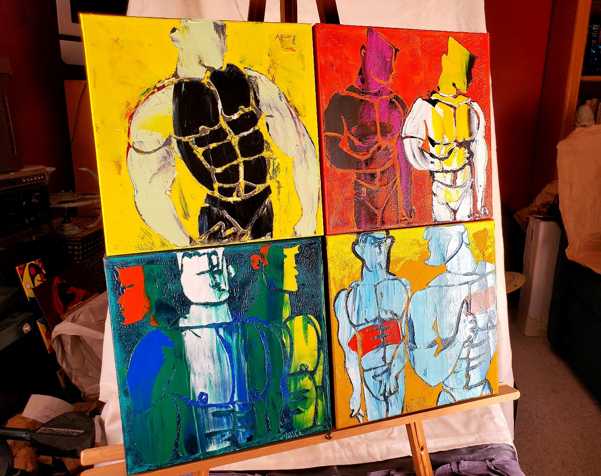

Eros: The Ralph Childs Collection

An Art Auction to Benefit Asians & Friends Chicago

March 20, 2021

Welcome Note

Ralph Childs, an elder of the social organizations, Asians & Friends Chicago (AFC) and IFCON, passed away suddenly in August of 2020. His estate donated several pieces of artwork to AFC in support of its efforts to build community among the LGBTQ Asian population in the Windy City. Those of us who knew Ralph appreciated his generosity, good humor and fun-loving spirit. Lesser known was his support of and participation in the visual-arts community.

Generally, Ralph loved to travel, meet people, take photos and explore the art scene. Many of the pieces reflect those passions. His taste gravitated to the more abstract, but also, as aligned with his sexual orientation, the male body. His family and friends say he was always interested in meeting the artist from whom he purchased work. Many of the pieces are signed by the artist and in the case of well-known illustrator, Jon Reich, a friendship developed.

Two pieces in the collection were purchased by Kevin Tam, a close friend of Ralph’s, with whom the two shared Ralph’s last Chicago home, a condo over the renowned Boystown area (today known as North Halsted). Kevin purchased the pieces while on a solo trip to Italy. They were prominently displayed in Ralph and Kevin’s Boystown home.

Finally, a special piece in the collection up for auction is a photograph of pop vocalist, Bette Midler, in costume during her 2018 Broadway run as the lead in Hello Dolly in New York City. Ralph saw Ms. Midler in the New York production and while attending a charity event for a local performing-arts group, he purchased the framed photograph—signed by Ms. Midler—for $500.

Though Ralph passed suddenly in Chicago, he left behind his sister Barbara, brother Bruce, nieces and nephews, and hundreds of friends from the AFC and IFCON communities, as well as dozens of others he met while on international cruises and trips abroad. He will not be forgotten.

Photo by Carter Martin

Ralph Childs
Bidding Rules:

All winning bids are considered final, with invoicing and billing to follow. Please note that we will take all bids seriously and will follow up accordingly. Here are AFC options for payment:

- PayPal via AFC’s website: www.afchicago.org.

- Mail with checks payable to Asians & Friends Chicago to P.O. Box A 3916, Chicago, Illinois 60690-3916.

- For post-event invoicing and follow-up, please provide your email to the chat room during the virtual Zoom event or in the Facebook comment page when you’ve been notified that you have won.

Delivery in the Chicago area will be free, but outside of the Chicago metro area will mean the cost of shipping will be added to the final bill.

“Silent” auction items will end bidding at 8:30 p.m., Sat., March 20, 2021, on the AFC Facebook Eros event page, while live bidding on certain items will continue in the chat room of the Zoom call through the live event on March 20.

Raffle tickets can be purchased at www.afchicago.org in $5 increments or five for $20. Buy a ticket and your name gets tossed into an automated randomizer. Winners will be identified electronically and announced by hosts during the live event.

Asians & Friends Chicago is a nonprofit registered in the state of Illinois. All donations are tax deductible towards any Illinois state filings. For more about AFC upcoming events, visit www.afchicago.org or AFC’s Facebook page.

Artwork Descriptions:

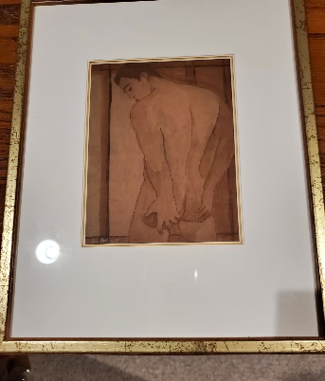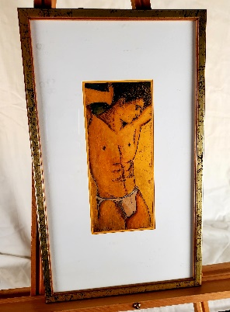

Art from Italy

Lot No. 104
Artist: Baruffaldi
Source: Bac Art Studio, Venezia, bacart.com
Description: 10” x 12”, male nude touching rear, sketch

Lot No. 106
Artist: Baruffaldi
Source: Bac Art Studio, Venezia, bacart.com
Description: 8.5” x 14”, male in jock strap

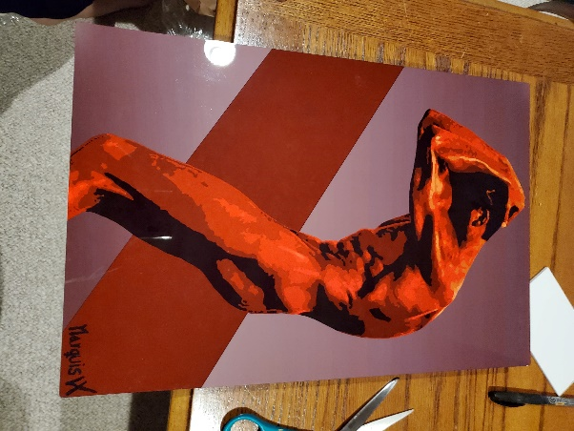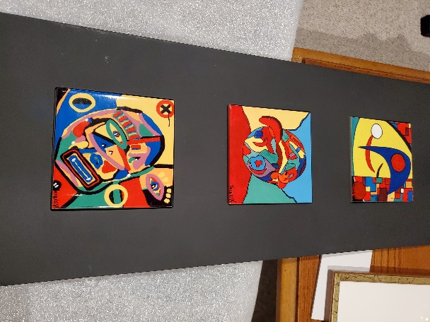

Acrylic Images

Lot No. 103
Artist: Marquis VX
Source: Unknown
Description: 12” x 18”, “The Thought,” male subject in red, acrylic on metal with 3-D mount

Lot No. 113
Artist: Marquis VX
Source: Unknown
Description: Triptic in 9” x 22” mounting, “God’s Creation,” abstract faces

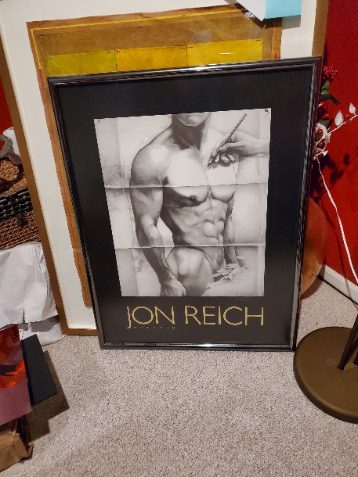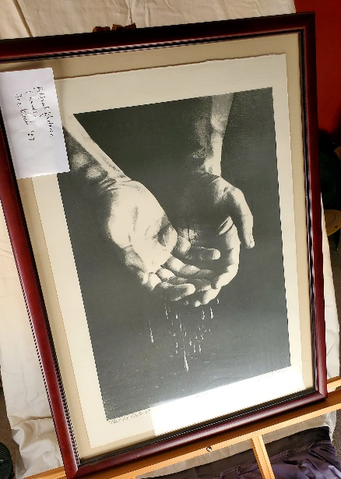

Jon Reich

Lot No. 102
Artist: Jon Reich
Source: Unknown
Description: 25” x 33”; Hand sketching a full, male nude; framed poster; signed by artist

Lot No. 108
Artist: Jon Reich
Source: Unknown
Description: 18” x 24”; “Political Rhetoric”; print/sketch of two hands, signed by artist

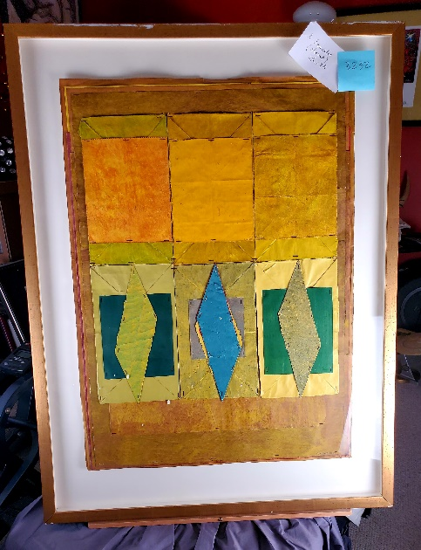

Multi-Media Framed Picture

Lot No. 112
Artist: A. Savelos
Source: Unknown
Description: 2.5’ x 4’; Abstract; multi-media

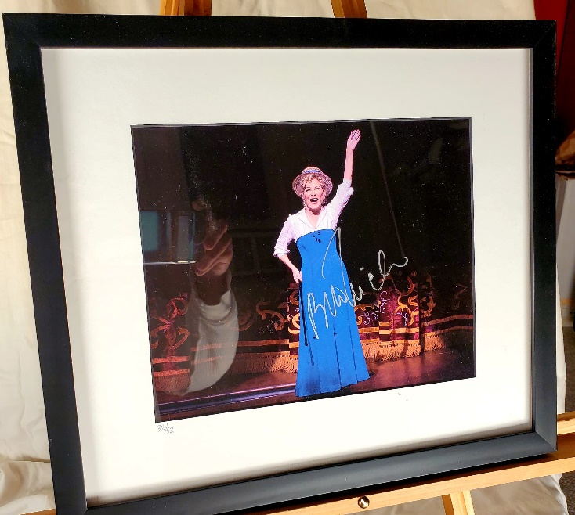

Hello Dolly Framed Photo

Lot No. 101
Artist: Unknown
Source: Unknown
Description: 13” x 16” framed photo of Bette Midler during her 2018 run as “Dolly” in the Broadway musical, Hello Dolly, in New York; purchased for $500 at a performing arts charity event

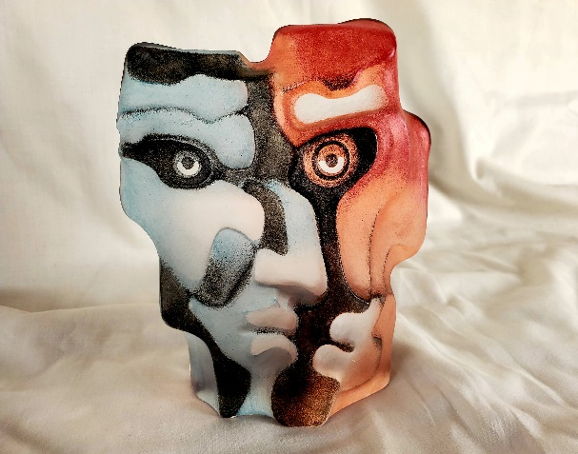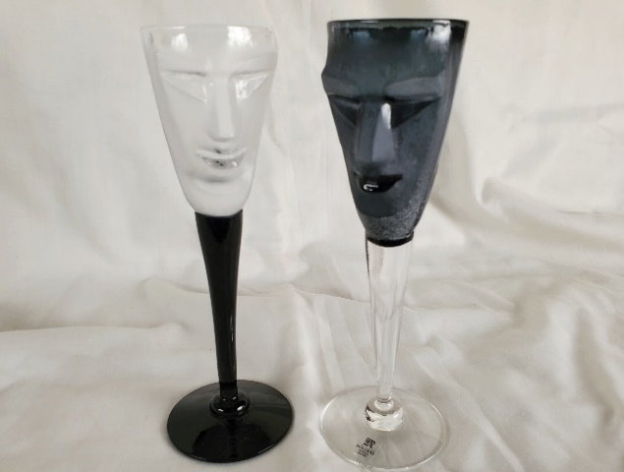

Acrylic Sculptures

Lot No. 108—Sold
Artist: Unknown
Source: Unknown
Description: 5” x 7”; acrylic sculpture of two faces in a single face

Lot No. 111
Artist: Unknown
Source: Unknown
Description: 6” tall x 5.5” in diameter; Two cordial glasses; One black face, one white face

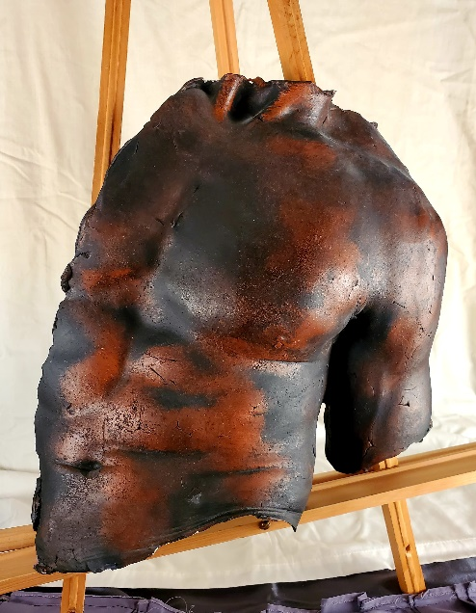

Forged Sculpture

Lot No. 105
Artist: Miket
Source: Havol Gallery, havolgallery.com
Description: 14” x 18”; Wall-mounted metal forged sculpture; partial male torso; dated 11/15

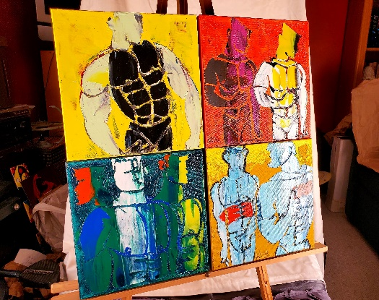

Male Nude Painted Series

Lot No. 107
Artist: Joey Wyneah
Source: Leigh Gallery, Chicago
Description: Four paintings, 10” x 10”
- The Green Man, 2018
- Summer Fever, 2019
- Torso in Green, 2018
- Double Image, 2018

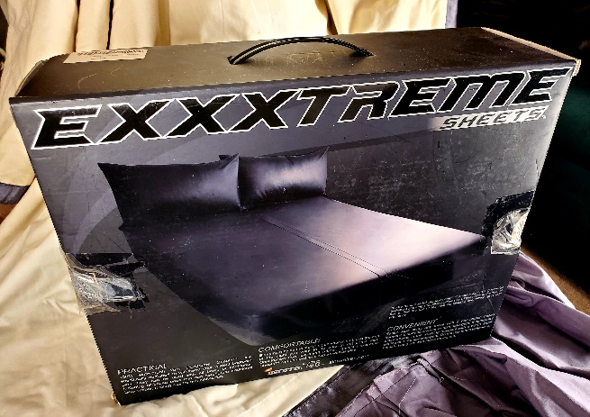

Rubber Sheets

Lot No. 114
Manufacturer: Exxxtreme
Description: Rubber bed sheets and pillowcases; queen-sized sheets with king-sized pillowcases; black

#

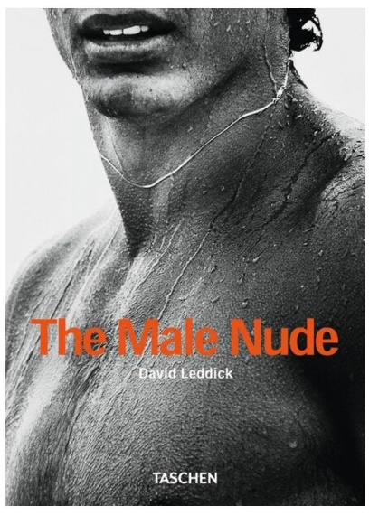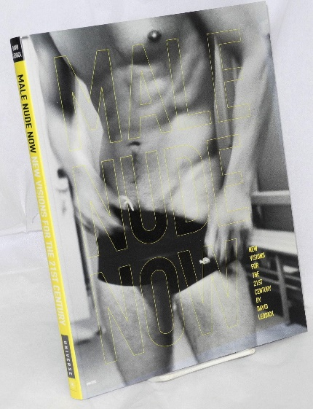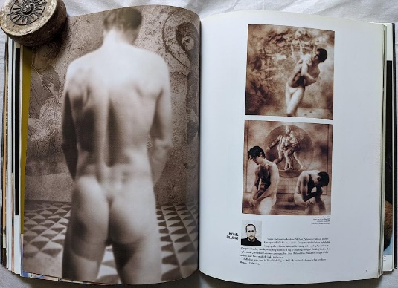

To add to the Eros theme, AFC member and co-chair of the Eros event, Oliver Aguilar, donated two photography books with male, nude themes.

Lot No. 110
The Male Nude by David Leddick

Lot No. 115
Male Nude Now by various artists

#

Lastly, John Kinyon, also an AFC and IFCON member, donated several items. He described what he has to offer, essentially three artwork groupings:

Two Framed Prints

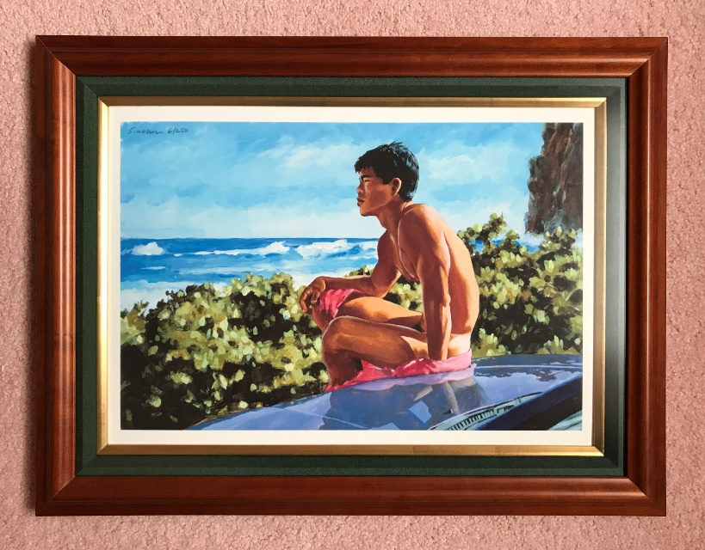

Lot No. 116
Artist: Douglas Simonson
Description: 18” x 23”; Cambodian Nude on Car

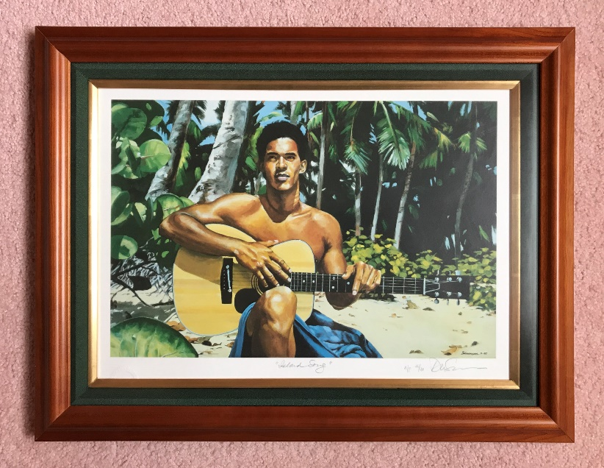

Lot No. 117
Artist: Douglas Simonson
Description: 18” x 23”; Island Song (Guitar)

Two framed prints by Douglas Simonson, both signed, limited edition, one is an artist's proof. They each depict an Asian male in an outdoor setting. Cost including custom framing and anti-glare, anti-UV glass was about $450 each. There is also a signed book showing the artist’s process—original photographs of the models (mostly Asian males) and the resulting artwork. He will include miscellaneous Simonson items such as postcards.

Embroidery

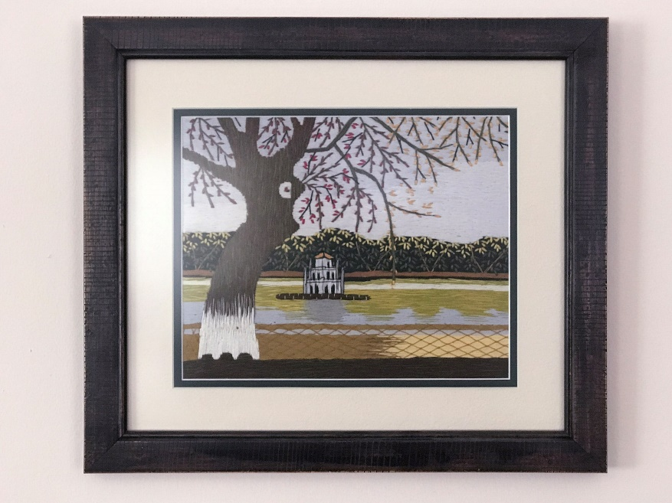

Lot No. 118
Description: 13” X 15”; One Pillar Pagoda, Hanoi

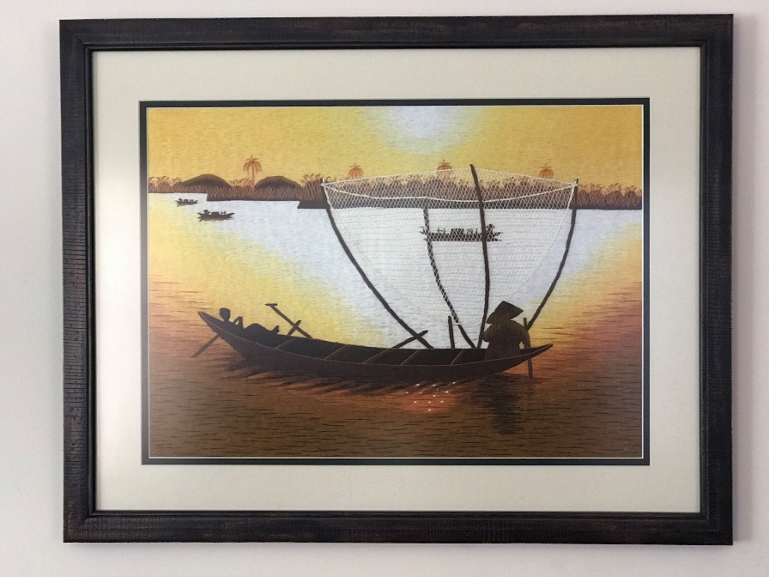

Lot No. 119
Description: 15” x 15”; Fishing Boat

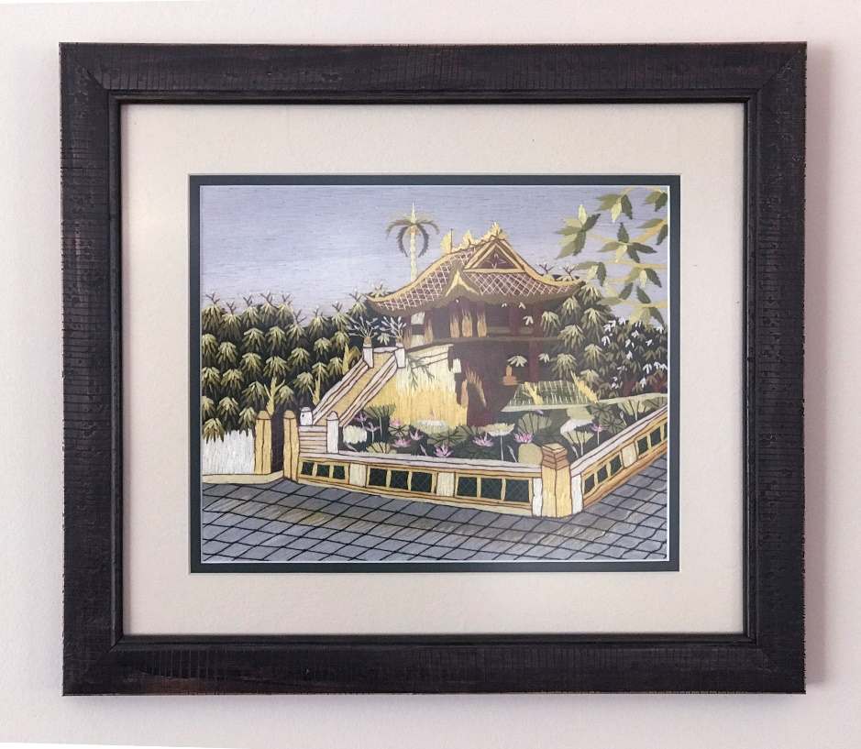

Lot No. 120
Description: 13” x 15”; Ngoc Song Temple

Three pieces of embroidery that John and his husband, Hung, purchased in Hanoi. They depict a one-pedestal pagoda, a shrine on the lake and a fishing scene. John also had them professionally matted and framed.

Framed Poster

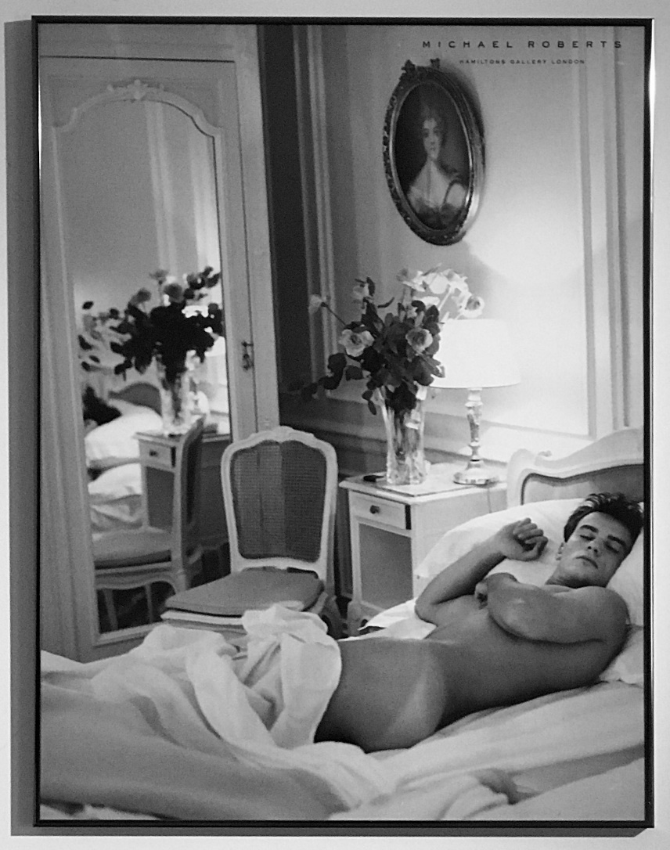

Lot No. 121
Source: Hamilton’s Gallery London
Description: 23” x 30”; A framed poster of a French male in bed.

#

AFC’s Eros Art Auction Committee:

Oliver Aguilar, co-chair
John McInteer, co-chair
Angel Abcede, operations and booklet
Rob Fore, event direction and production
Brad Held, finance and raffle
Michael Nemeth, event production
Wei-Ming Su, event production
Curtis Tom, event production

Special Thanks:

Bruce Childs
John Kinyon
Bill Quirk
Kevin Tam
Barbara Childs Wallace

#

Asians & Friends Chicago is a nonprofit registered in the state of Illinois. All donations are tax deductible towards any Illinois state filings. For more about AFC upcoming events, visit www.afchicago.org or AFC’s Facebook page.

Thanks to everyone who participated in the bidding, to the AFC Board members and volunteers who helped out for this event.

Sincerely,

AFC Board of Directors
March 20, 2021

